**PERSONAL INFORMATION**

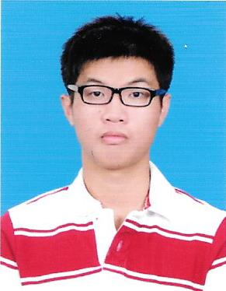

Name : Chung Chee Hoe

Address : 34, Jalan Damai Perdana 3/2F, Bandar

Damai Perdana, Cheras 56000 Kuala

Lumpur

Contact Number : 012-2415563 (HP)

E-mail Address : [cheehoe_93@hotmail.com](mailto:cheehoe_93@hotmail.com)

Place of Birth : Kuala Lumpur

Race : Chinese

Religion : Buddha

Status : Single

Date of Birth : 25th May 1993

Age : 24

Gender : Male

Nationality : Malaysian

**Objective**

Seeking for internship job position for 3 months (13 weeks) start date from 29th May 2017

– 25th Aug 2017, seeking for new I.T job industry training experiences.

**EDUCATION BACKGROUND**

Highest Education : September 2016 – December 2018 (Studying)

Qualification : Bachelor’s Degree

Field of Study : Bachelor in Computing

Institute/ University : **SEGI College Kuala Lumpur**

CGPA : Not Available Yet

2. Second Highest Education : Octorber 2013 – December 2015

Qualification : Diploma In Computer Science

Field of Study : I.T

Institute/ School : SEGI College Kuala Lumpur

CGPA : 2.95/4.00

**Miscellaneous**

* Able to speak Mandarin and English .
* Able to work efficiency in a team
* Punctual
* Hardworking and willing to learn

**Languages** (Proficiency: 0=Poor - 10=Excellent)

|  |  |  |
| --- | --- | --- |
| **Language** | **Spoken** | **Written** |
| Mandarin | 10 | 7 |
| Bahasa Malaysia | 6 | 5 |
| English | 8 | 7 |

**Skills & Experience.**

* Microsoft SQL
* Microsoft Visual ASP.net
* HTML (Basic) Coding / Design
* Computer Hardware maintain
* Intermediate in Microsoft Offices, Excel and PowerPoint